Technical Report

Project Exam 1

Frode Karlsen

Word count

Summary: 177 | Main text:500

Table of Contents

1. Summary ……………………………………………………………

2. Body ………………………………………………………………….

2.1 Introduction ……………………………………………

2.2 Main ……………………………………………………….

2.2.1 Functional Specification …………………………

2.2.2 Research, prototype & wireframing ………..

2.2.3 Design …………………………………………………….

2.2.4 Programming ………………………………………….

2.2.5 Implementation ………………………………………

2.3 Conclusion ………………………………………………

3. References ………………………………………………………

4. Appendices ……………………………………………………..

# 1. Summary

This is a report of Project Exam 1 for front end development at Noroff. The purpose of the project is to create a microsite for NASA or SpaceX that focuses on space technology. I will go through my process based on everything we have learned this year, including topics such as planning, functional specification, Gantt chart creation, target audience research, design process, HTML/CSS/JS, SEO, content strategy, interface design, implementation/rollout and conclusion.

I decided to create a microsite for NASA that focuses on the Hubble Telescope, which has its 30th anniversary this year. Science and technology that comes together to explore the universe is truly interesting, so I wanted to highlight the importance of the Hubble Telescope. Going through Hubble’s history through a timeline, information about launches, have cool images on display, and interaction with the community of the site was something I want to focus on.

I will take you through my process week by week, and go into further detail in each individual section of my report. Detailed description can be found in table of contents.

# 2. Body

## 2.1. Introduction

I categorized my report into five sections, which is as following:

* Functional specification
* Research, prototype & wireframing
* Design process
* Programming
* Implementation

My interpretation of the assignment was to display everything we have learned this year, as well as sharing my thoughts on the entire process through this report. I was going to create a microsite for a specific target audience through planning and research. Not much more to say, so let’s just dive in!

## 2.2. Main section of report

## 2.2.1 Functional Specification

**Planning Phase**

To start with I created user stories and gave them all an ID from 1 to 26:

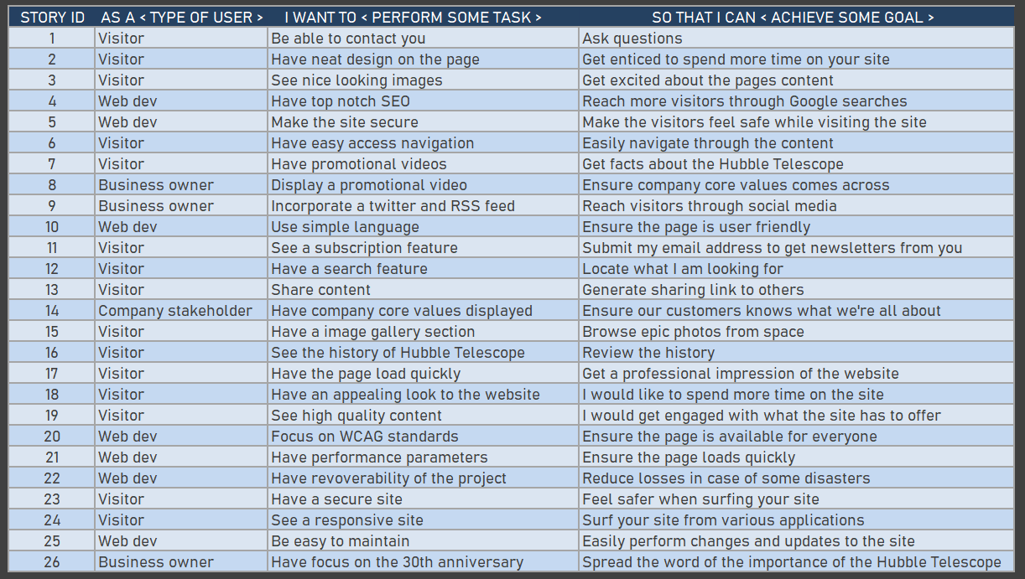

The general idea in the planning phase was to get these sorted and divided, but to keep things simple I put the development plan in four initial phases: planning phase, design phase, development phase and testing & launch. Instead of having all microtasks listed inside the Gantt chart, I decided to make them less specific in my task list, but note the smaller tasks into the ‘schedule’ section of the Gantt to describe what should be done during each task section. With that in mind I created 6 main tasks and split them up into smaller tasks into the Gantt chart:

• **Planning**: functional specification, gantt chart.

• **Research**: general research, target audience, card sorting, information architecture, personas, scenarios and storyboards.

• **Design**: general research, layouts and images, fonts and colors, navigation design and interaction design.

• **Wireframe**: wireframe creation and prototyping.

• **Programming**: research & content creation, front page (HTML&CSS base), image of the day page (HTML&CSS base), image gallery & video page (HTML&CSS base), article page (HTML&CSS base), choosing relevant API, JS coding, HTML review, CSS review, @media coding.

• **Implementation**: bugfix, user testing, rollout and report writing.

I also created a weekly schedule from week 1 to 5 and split up into daily workplan for each smaller task. Upon completion the scheduled task will get a red color when done to display progress of the project, which is displayed in the Gantt chart provided in this deliverable task.

**Functional Specification**

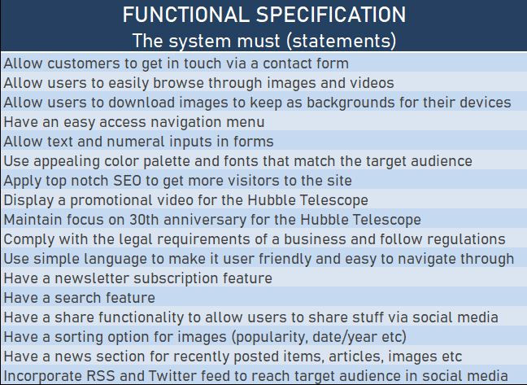

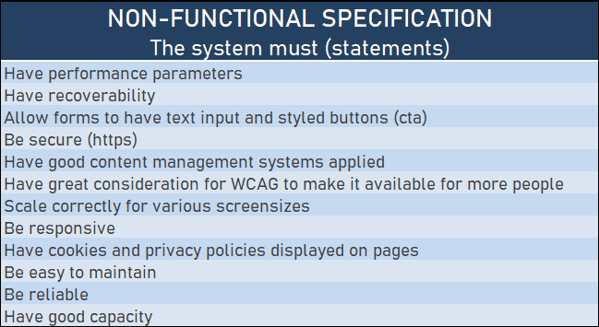

**Themes**

**1. Hubble Telescope’s 30th anniversary**

This is the main goal of the microsite. I want a site that celebrates the 30 years of the Hubble’s existence and its unique history. The microsite will contain interesting articles, but in particular have a clear focus of the fantastic images the telescope has taken and details behind the images.

**2. Social media presence**

This is another focus area of the microsite. Here I plan to have an RSS feed on the page and twitter feed directly from NASA. Visitors are also allowed to share stunning images on their Facebook page, download images as backgrounds to their smart phones/tables/PCs and rate images. Another idea to spread the page through social media would be to have quizzes with prizes such as NASA t-shirts and other apparel.

**3. Display company core values**

NASA is all about integrity, safety, teamwork and excellence. These core values are set in stone to ensure successful missions. However, they are in the end all about exploration, curiosity and education. Their work is a study of the universe we live in and space exploration. I will focus on finding our inner child via imagination. Who hasn’t pretended to be an astronaut as a kid?

**Hubble Telescope’s 30th anniversary**

|  |  |
| --- | --- |
| FEATURE | WEBSITE DESIGN |

Epics

• As a visitor, I want an appealing website, so that I will get engaged by its content.

• As a visitor, I want engaging content, so that I will visit the site every now and then.

User Stories

• As a visitor, I want nice images displayed, so that I will get enticed to browse through the content on your website.

• As a web dev, I want a nice looking website, so that we can represent NASA in the best way possible to the public.

• As a web dev, I want a nice layout that emphasizes the most important parts of the pages.

• As a web dev, I want the company colors to shine through, so that it feels familiar to the users.

|  |  |
| --- | --- |
| FEATURE | NAVIGATION |

Epics

• As a visitor, I want a navigation menu, so that I can easily browse through your pages.

• As a web dev, I want a navigation menu, so that our website looks professional.

User Stories

• As a visitor, I want a nice looking navigation menu, so that I swiftly can browse through the various pages/sections of the site.

• As a web dev, I would like the navigation menu to include a search bar so that users can swiftly search through the pages contents.

• As a web dev, I want a hamburger menu for mobile and smaller screen resolutions, in order to maintain easy navigation on the site.

|  |  |
| --- | --- |
| FEATURE | CONTACT FORM |

Epics

• As a visitor, I want a contact form, so that I can get in touch with you in case I have any questions.

User Stories

• As a visitor, I want a contact form, so that I can get in touch with you if I have any questions or leave feedback.

• As a web dev, I would like our visitors to be able to contact us, so that we are in better touch with the customer base.

• As a visitor, I would like confirmation that the message have been sent, so that I can be notified about this.

## 2.3. Conclusion

Start writing here

# 3. References

Start writing here

# 4. Appendices

Start writing here